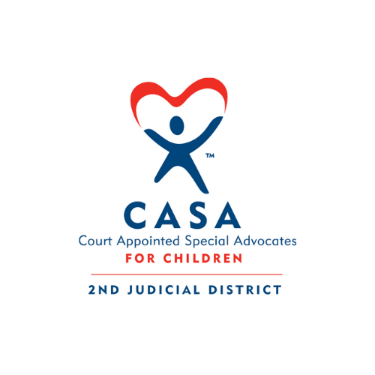

Grievance Policy
Second Judicial District CASA Program
The Second Judicial District CASA Program is committed to ensuring that any grievance raised by a staff member, volunteer, client, or community member is addressed promptly, fairly, and with respect for all parties involved.

1. Initial Grievance Process
Whenever possible, the grievance should first be discussed directly among the individuals involved to seek an informal resolution.
If the issue cannot be resolved at that level, the matter should be brought to the attention of the Executive Director of the Second Judicial District CASA Program for review and discussion.

2. Written Grievance and Follow-Up
If further action is needed, the individual filing the grievance (the “griever”) should submit a written letter to the Executive Director that includes:
- A clear description of the grievance
- The dates, times, and outcomes of any prior discussions or meetings about the issue
- Any other relevant information or supporting documentation
The Executive Director will review the information and make a determination based on the facts and agency policy within five (5) business days of receiving the written grievance.

3. Final Resolution
If the griever is not satisfied with the Executive Director’s decision, the written grievance will be forwarded to the CASA Board of Directors for review.
The Board may choose to meet with the griever, the Executive Director, or other relevant parties as needed.
The Board of Directors will make a final decision within thirty (30) days of receiving the grievance, and that decision will be considered final.

4. External Complaint Options
Program participants also have the right to file a complaint directly with the following agencies if they believe their rights have been violated or their grievance has not been adequately addressed by the Second Judicial District CASA Program:

Idaho Council on Domestic Violence and Victim Assistance (ICDVVA)
P.O. Box 83720
Boise, ID 83720-0046
Phone: (208) 332-1540
Website: https://icdv.idaho.gov
U.S. Department of Justice, Office for Civil Rights (OCR)
Office for Civil Rights
Office of Justice Programs, U.S. Department of Justice
810 7th Street NW
Washington, DC 20531
Phone: (202) 307-0690
TDD: (202) 307-2027
Email: OCR@usdoj.gov
Website: https://www.ojp.gov/program/civil-rights/overview
Individuals may contact these agencies directly for guidance on how to file a complaint or to obtain complaint forms and submission instructions.

